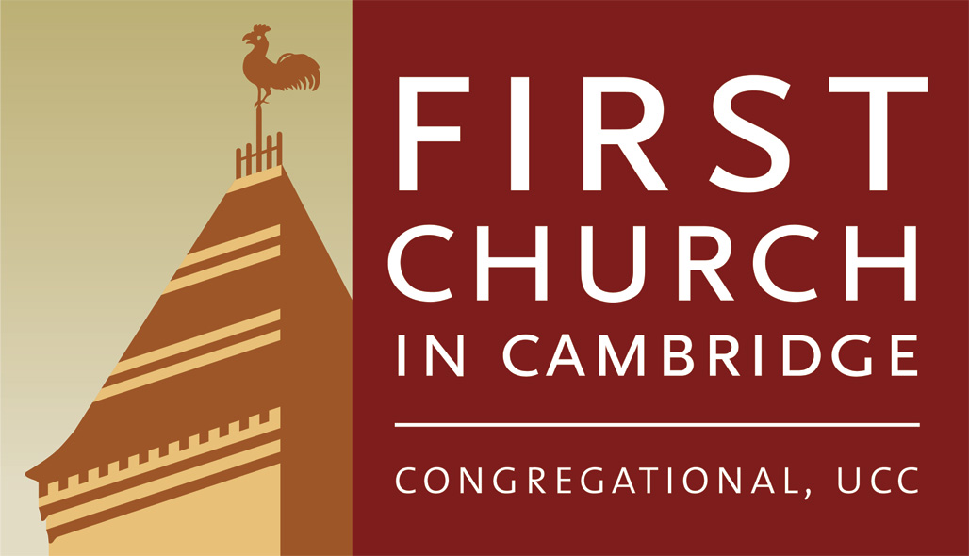
The Call to Return: Spiritual Reflections on Racial Justice

Throughout the duration of this programming at First Church, we will explore the theme of “Returning to God: Spiritual and Theological Reflections on Racial Justice.” In the Judaeo-Christian tradition, the Hebrew people went through cycles of closeness and obedience to God and the covenant. During these periods, the community was governed by righteousness, justice, and equality, all of which were pervasive throughout the community. But as time went on, they would eventually abandon God; by straying and entering periods of idolatry and rampant injustice, which alienated them from their truest selves. This distance eventually required them to return.

How does this apply to us? In today’s world, many of us understand how structural racism is one of the biggest enemies we face that leads to profound states of separation and suffering. Though we ourselves may be conscious and aware of the disparities of race in America, we are all a part of the system. Therefore, this requires us to have an understanding of our location and privilege, and strive to transform and evolve spiritually. Many of us have been a part of communities that have strayed away from God’s vision of justice, righteousness and wholeness in our individual and collective lives. Therefore, we will be looking at God’s invitation to return. How can we return to God in our daily work for racial justice? How can we return to our truest and fullest selves in ways that can celebrate and manifest diversity in our relationships and community? We will explore together how our scriptural and theological tradition shows us that returning to God involves turning towards a place of harmony, inclusion, and the abolition of structural racism in our communities. It also demands that we reframe our own conceptions of God, by taking a critical look at the racial bias that has existed throughout the Christian tradition. We will explore how theology has influenced theories of race, and also the contribution of African peoples to theology and the Biblical tradition of which we are apart. This shared journey will allow us to see that we are a part of an unfolding Biblical story, and also it will help us strengthen our faith and bonds with others, while restoring our common hope and joy.

Our programming will be centered around weekly themes. Returning to God is ultimately about honoring the Mosaic covenant, as well as the Greatest Commandment, which is to love God with all our heart and soul, and to love our neighbors as ourselves. Here we return to a place where the divine reality and cosmic Law of Love supersedes all else. Jesus’ ministry was centered around calling people to return to their divine consciousness (their greatest selves) and the law of love.

Many of our sessions will be discussion based and will conclude with a commitment that we will engage in during the following week; a ritual or practice of some sort. We will also establish a group covenant amongst ourselves and commit to creating open spaces where people can express themselves without fear or trepidation. Participants should expect to enter a place of introspection, self-examination, self-evaluation, and coming to terms with one’s past, actions, behaviors and attitudes, and also one's internal beliefs about God. We will begin that examination with ourselves by asking questions such as: Who am I? How have I treated others? What systems have I and my ancestors been a part of? What info do I gather as a result of looking at myself.

Returning to God won’t necessarily mean the same thing for each person. But universally, returning to God, or re-focusing on the divine virtues we hold dear, involves growing through a process of transformation. Ultimately our goal is to be transformed, and more connected to ourselves and the Spirit of life. Returning to God is a constant process. We can never “arrive” per say, but we are always “in process”, growing in our relationship with the creator. In that journey we must make room for our imperfections and understand that this work takes time. I pray this program can help people to shift their individual and collective consciousness in order to enter into a new moral and spiritual space, and a deeper relationship with God and marginalized communities.

TOPICS AND THEMES WE WILL DISCUSS EACH WEEK
(Each section will last 1 or 2 weeks)

1. Week 1/2- Intro
Focus- “Reframe our ideas about God and race in our culture and faith tradition.”
- Importance of this work. What is the general problem and what are we doing to address it? We will first do some theological reframing, and contextualize this work biblically to connect it to what’s going on in our world.
- We will explore our preconceived notions and implicit beliefs about God’s racial identity, and how images of God and Christ have been falsely portrayed in Western culture.
- We will explore the African origins of Christianity and Judaic history to bring to light hidden truths to show that we are all a part of an unfolding biblical narrative.
- It is important to understand how race/ethnicity has influenced theology and how theology has molded race in our worldviews. Although we may personally reject those harmful theological theories about race. We have to see how it still pervades our culture. This is the very conditioning that needs to be undone. We have to be aware of this before we can do the work of returning. This program is built upon these ideas because we don’t want to return to the false or harmful idolatrous God that gave sanctioning to racism or injustice. Here we have to recognize which God we have been serving and do choose to serve going forward.
- We will wrestle with the tension of traditional theological language and the racism that the Christian tradition has supported. We acknowledge this history so we can ascend beyond it. This will help us to come into awareness of God.

2. Week 2/3- Repentance.
Focus- “Becoming Truth Tellers and Aware of our Sins/Shortcomings”
- What scripture and tradition calls repentance and renunciation of racism. We will explore repentance together for the ancestral legacy and sin of white supremacy. Which is a form of idolatry that puts humans on the level of God. We will discuss the moral and spiritual benefits of repentance. As well as examples of repentance in the Bible.
- What is repentance and how does this help communities and believers to transform?
- Repentance can be a difficult act, but it is incredibly powerful and it helps people to re-center and reconnect with themselves and others.
- We will make connections and explore examples of repentance and how it has been pursued in other societies/cultures in response to some sort of injustice that has occurred.

3. Week 4/5- Reorientation.
Focus- Understanding Love as the foundation of reality and committing to the Law of Love and discipleship.
- In our tradition this is how we become followers of God.
- Spiritually we need to explore the two wills, “ Will to Love vs. Will to dominate”, and how this plays a role in all human interactions, especially interactions between races in our culture. We see this tension between these two “wills” all throughout the Bible. This will help us to embrace unity and develop our divine consciousness.
- Reorientation is often a tumultuous process, a lot of tension fears and anxieties may arise. We will break old bonds and habits and form new ones.
- Divine reality of Love not just reorienting ourselves to be more loving, but reorienting ourselves to the cosmic law of love, which is interwoven into God’s truth.

4. Week 6/7- To Be Made Holy.
Focus- This is what our tradition calls “SANCTIFICATION “
- Becoming holy is not a single event. It is a constant lifelong process that requires a person to constantly be in communication and relationship with God, and who God has called us to become at that moment in our life. This requires believers and communities to develop regular rituals and behaviors to sustain holiness. In the Bible we will explore how some communities did ritual just for the sake of ritual (which was not pleasing to God), versus others who engaged in rituals and practices with the intent of loving others and honoring God with their full hearts. We will strive for the latter.
- This is healing and healthy for us. In the process of being made Holy, the believer is sustained and strengthened by the Power of the Holy Spirit to search for and seek a new spiritual path.

5. Week 8/9- Growing in our Reliance on Grace.
Focus- This is What our tradition calls “JUSTIFICATION”.
- The tradition defines justification as removing the guilt/penalty of sin. (Which can be harsh language), where a believer becomes sanctified and justified through the saving grace of God. They are then expected to be committed to a new divinely sanctioned path. On that path, God continuously pours grace into us. On this path there is a new responsibility of those people going forward after stepping into this new relationship with God to remember to not lose sight of the path.
- We rely on Grace because we are imperfect, we will fall short, but God’s grace allows us to know that we must keep working at becoming holy, because God loves us enough to allow and encourage us to keep working at it.

6. Week 10/11- Becoming Transformed, Joyful and Free.
Focus- this is what our tradition calls ASCENSION
- This is a continual process and not a single event. Justification is a part of our path to transformation, but then we are only truly transformed when we walk that path and are strengthened by the continual practice of what we have dedicated and reoriented ourselves to. This practice will be different for each person.
- Transformation involves being set on a new path in our lives and with God.
- Transformation brings joy, peace, and freedom through the realization of self, the interconnectedness of all people and life (dissolution of boundaries).

7. Week 11/12- Returning to God (Physically and Spiritually)
- This segment will consist of a lot of dialogue and reflection between participants, so people can track how they have been changed thus far. What have the weekly rituals and sessions been like for you? How do you feel like you have grown, or been transformed in your relationship to God, yourself, and others? What has returning felt and meant like for you?

All of our sessions will be accompanied by various texts that will be assigned at the end of each session; Biblical texts or some other source.

Rituals
- Not each session will have a ritual but during the ones that do, each will focus on the theme and allow people to center themselves and sit and reflect on the work we have done. Participants are also invited to bring their own ideas or experiences with rituals to the group and suggest them to Carlyle so we can incorporate them into our program.
- Examples: Prayer, contemplation, body work, group reflections, expressions of gratitude, expressions of repentance, vocalizing upcoming commitments for the week and why.
- Other rituals include new ways to express love and brainstorming ways we can be more loving in our lives and in our community. The goal is to make these theological themes concrete and allow people to act them out in some way which helps us on this path to transformation and physical and spiritual return to God.

